**User Manual**

**Short Cuts and Keys**

Please pay attention to the following short keys for better performances of the system:

|  |  |  |
| --- | --- | --- |
| Short cuts and keys | | Description |
| Strg + 1 | * Kasset 1 | |
| Strg + 2 | * Kasset 2 | |
| Enter | * Find result * Add orders * Add new customer * Edit customer * Add menu * Edit menu | |
| F1 | * New Customer | |
| F2 | * Refresh page * Clean search customer | |
| F3 | * Display orders * Edit customer | |
| F9 | * Save Orders * Print | |
| F11 | * Full Screen | |
| ESC | * Refresh page * Go back to searching page * Close customer edit page | |
| TAB | * Next button * Next value * Next | |
| Strg + R | * Full refresh page | |
|  |  | |

**Explanation**

1. **Search customer number**
2. If the customer number is not found, a new customer needs to be created as below:

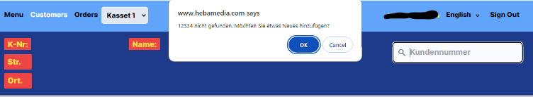

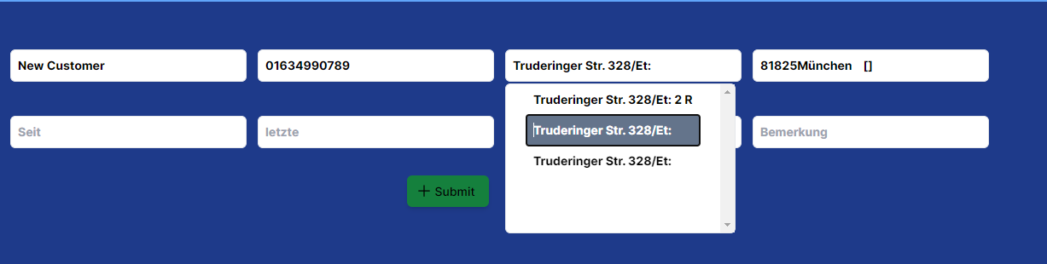

1. If the number found, the customer information and last orders along with discount.

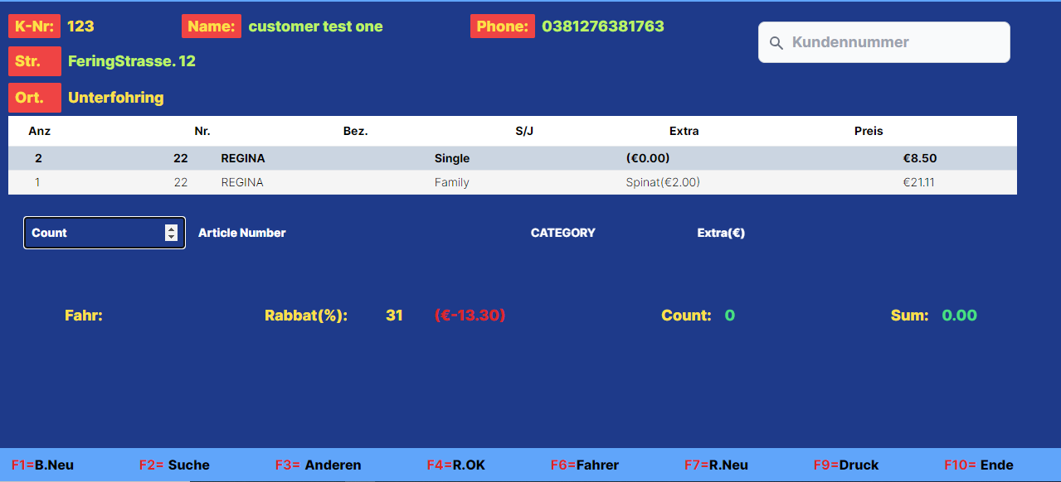

1. Add new order

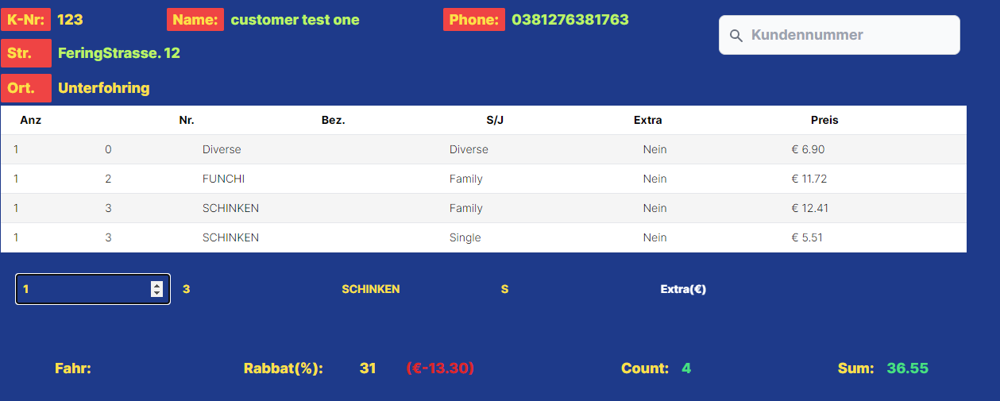

1. Edit Customer